 | 7.1.36 Editors - 3D Viewport - Header - Lattice - Edit mode - Lattice menu
Table of content
Detailed Table of content 1
Edit Mode - Lattice Menu 4
Transform submenu 4
To Sphere 4
Shear 5
Bend 6
Push/Pull 6
Warp 7
Randomize Transform 7
Move Texture Space 8
Scale Texture Space 9
Set Dimensions 10
Mirror submenu 11
Interactive Mirror 11
X Global, Y Global etc. 11
Snap submenu 11
Snap 11
Flip submenu 12
Last Operator Flip (Distortion Free) 12
Single Operators 12
Make Regular 12
Hooks 12
Make Vertex Parent 13

Detailed Table of content

Detailed table of content
Detailed Table of content 1
Edit Mode - Lattice Menu 4
Transform submenu 4
To Sphere 4
Usage 4
Last Operator To Sphere 4
Factor 4
Mirror Editing 4
Proportional editing 5
Proportional Falloff 5
Proportional Size 5
Connected 5
Projected(2D) 5
Shear 5
Last Operator Shear 5
Offset 5
Axis 5
Axis Ortho 5
Orientation 5
Mirror Editing 5
Proportional editing 6
Proportional Falloff 6
Proportional Size 6
Connected 6
Projected(2D) 6
Bend 6
Push/Pull 6
Last Operator Push/Pull 6
Distance 6
Mirror Editing 6
Proportional editing 6
Proportional Falloff 6
Proportional Size 6
Connected 7
Projected(2D) 7
Warp 7
Last operator Warp 7
Warp Angle 7
Offset Angle 7
Min 7
Max 7
Randomize Transform 7
Last Operator Randomize Transform 7
Amount 7
Uniform 7
Normal 7
Random Seed 8
Move Texture Space 8
Last Operator Move 8
Move 8
Orientation 8
Mirror Editing 8
Proportional editing 8
Proportional Falloff 8
Proportional Size 9
Connected 9
Projected(2D) 9
Scale Texture Space 9
Last Operator Resize 9
Scale 9
Orientation 9
Mirror Editing 10
Proportional editing 10
Proportional Falloff 10
Proportional Size 10
Connected 10
Projected(2D) 10
Set Dimensions 10
Last Operator Set Dimensions 10
New Dimensions 10
Mirror submenu 11
Interactive Mirror 11
X Global, Y Global etc. 11
Last Operator Mirror 11
Orientation 11
Constraint Axis 11
Snap submenu 11
Snap 11
Last operator Snap Selection to Cursor 11
Offset 12
Rotation 12
Flip submenu 12
Last Operator Flip (Distortion Free) 12
Flip Axis 12
Single Operators 12
Make Regular 12
Hooks 12
Hook to New Object 12
Hook to Selected Object 13
Last Operator Hook to Selected Object 13
Active Bone 13
Hook to Selected Object Bone 13
Assign to Hook 13
Remove Hook 13
Select Hook 13
Reset Hook 13
Recenter Hook 13
Make Vertex Parent 13

Edit Mode - Lattice Menu

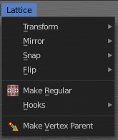
In Edit Mode you will also see a add menu for some object types. The number of objects that you can add is limited to the same object type that you are in edit mode with. You can just add mesh geometry to a mesh geometry. And just curve geometry to curve geometry.

The added objects in edit mode becomes part of the current object geometry.

Transform submenu
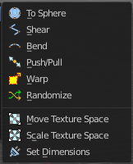

To Sphere
Shapes a selection of objects into the shape of a sphere. The calculation happens with the object origins.
In Object mode this tools requires to have more than one object selected.

Usage

Select the vertices, activate the tool, then drag the mouse in the 3D viewport. In the header you will read the current factor then. Which tells you how close you are towards the sphere shape.


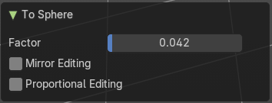
Last Operator To Sphere

Factor
The factor to transform the selection into a shape form.

Mirror Editing
Enable mirror editing.

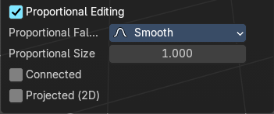
Proportional editing
Enables proportional editing. Activating proportional editing reveals further settings.

Proportional Falloff
Adjust the falloff methods.

Proportional Size
See and adjust the falloff radius.

Connected
The proportional falloff gets calculated for connected parts only.

Projected(2D)
The proportional falloff.

Shear
Shear shears the selection.
In Object mode this tools requires to have more than one object selected.
The shear tool works along a imaginary 2d plane. The shear axis controls if the items are sheared along the x or the y axes of this plane. This is the plane along which the transformation happens. You can shear along the x or the y axis of this plane.
To make things even more complicated, the orientation of this imaginary plane is defined by the Axis and Axis Ortho items below.

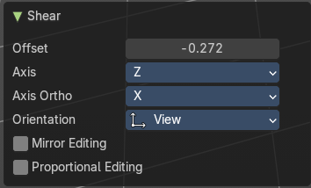
Last Operator Shear

Offset
Adjust an offset.

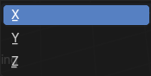
Axis
Defines one axis of the imaginary shear axis plane.

Axis Ortho
Defines the other axis of the imaginary shear axis plane.

Orientation
Choose the orientation for the shear action.

Mirror Editing
Enable mirror editing.

Proportional editing
Enables proportional editing. Activating proportional editing reveals further settings.

Proportional Falloff
Adjust the falloff methods.

Proportional Size
See and adjust the falloff radius.

Connected
The proportional falloff gets calculated for connected parts only.

Projected(2D)
The proportional falloff gets calculated in the screen space. Depth doesn't play a role. When it's in the radius, then it gets calculated.

Bend
Bends the selection.

Push/Pull
It pushes or pulls the object positions relative to the center of the selection.
In Object mode this tool requires to have more than one object selected.

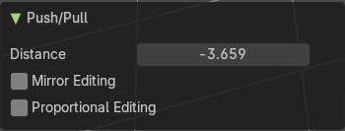
Last Operator Push/Pull

Distance
Adjust the distance of influence of the tool.

Mirror Editing
Enable mirror editing.

Proportional editing
Enables proportional editing. Activating proportional editing reveals further settings.

Proportional Falloff
Adjust the falloff methods.

Proportional Size
See and adjust the falloff radius.

Connected
The proportional falloff gets calculated for connected parts only.

Projected(2D)
The proportional falloff gets calculated in the screen space. Depth doesn't play a role. When it's in the radius, then it gets calculated.


Warp
Warps a mesh selection between two defined points.

Last operator Warp

Warp Angle
The strength of the warp effect

Offset Angle
An offset angle to bend sidewards.


Min
The start point.

Max
The end point.

Randomize Transform
This tool allows randomizes the positions of the selected vertices.


Last Operator Randomize Transform

Amount
Adjust the amount.

Uniform
The uniform offset distance.

Normal
Align the offset direction to the normals.

Random Seed
The seed value for randomization.


Move Texture Space
This tool relies at the move tool. With the difference that it moves the texture space instead of the object. It has also a very special use case, and just works with a material with a Texture Coordinate / Generated node. And requires to have the shading at Material or Rendered to see a result in the viewport.
In the viewport you will see the UV cage in black color. In the header you will see the values for the current position of the UV cage.
Note that once done and applied, there is no way to reset the UV cage back to zero. When you repeat the operation, then the values will start at 0 again. Even when the UV cage is already offset.


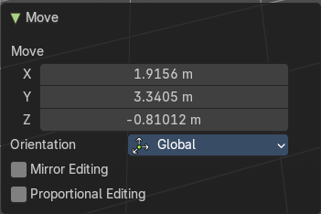
Last Operator Move

Move
Adjust in which directions you want to transform.

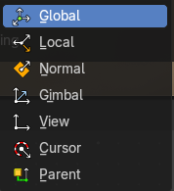
Orientation
Choose the orientation.

Mirror Editing
Enable mirror editing.

Proportional editing
Enables proportional editing. Activating proportional editing reveals further settings.

Proportional Falloff
Adjust the falloff methods.

Proportional Size
See and adjust the falloff radius.

Connected
The proportional falloff gets calculated for connected parts only.

Projected(2D)
The proportional falloff gets calculated in the screen space. Depth doesn't play a role. When it's in the radius, then it gets calculated.


Scale Texture Space
Scale Texture space is similar to the Move texture Space. With the only difference that it scales the UV space instead of moving it.
This tool relies at the scale tool. With the difference that it scales the texture space instead of the object. It has also a very special use case, and just works with a material with a Texture Coordinate / Generated node. And requires to have the shading at Material or Rendered to see a result in the viewport.
In the viewport you will see the UV cage in black color. In the header you will see the values for the current position of the UV cage.
Note that once done and applied, there is no way to reset the UV cage back to zero. When you repeat the operation, then the values will start at 0 again. Even when the UV cage is already offset.


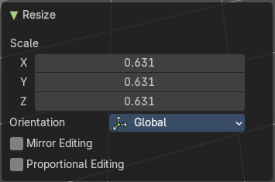
Last Operator Resize

Scale
Adjust in which directions you want to transform.

Orientation
Choose the orientation.

Mirror Editing
Enable mirror editing.

Proportional editing
Enables proportional editing. Activating proportional editing reveals further settings.

Proportional Falloff
Adjust the falloff methods.

Proportional Size
See and adjust the falloff radius.

Connected
The proportional falloff gets calculated for connected parts only.

Projected(2D)
The proportional falloff gets calculated in the screen space. Depth doesn't play a role. When it's in the radius, then it gets calculated.


Set Dimensions
Edit Mode Only!
Normally all scale operations in Bforartists are relative to the current selection and dimensions. And you always start with a relative value of 1.
Set dimensions allows to scale mesh selections in absolute world values. No matter how the initial values are. The new values gets set in the Last Operator.
Set dimensions is an add-on. You can turn it off in the add-ons section of the user preferences when you want.

Last Operator Set Dimensions


New Dimensions
When you activate the tool then you will see the world coordinates of the selection. Change the values to other world coordinates.

Mirror submenu

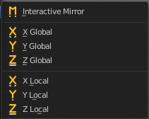
Mirror mirrors the selected geometry along the defined axis.

Interactive Mirror
Mirror by hotkeys. You activate the tool, type in x for x global for example, or x x for x local. And the selection gets mirrored

X Global, Y Global etc.
Mirrors the selection around the chosen axis.

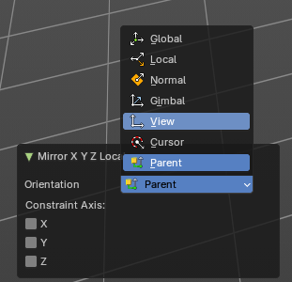
Last Operator Mirror
The Last Operator Mirror panel gives you tools to adjust the mirror action.


Orientation
Orientation is a drop-down box . Choose the type of orientation for the mirroring action.

Constraint Axis
Constraint Axis gives you again the possibility to define the mirror axis. You can choose more than one axis here.

Snap submenu


Snap
Choose several methods to snap one element to another. The menu items should be self explaining.

Last operator Snap Selection to Cursor
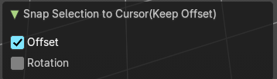
Some snap operations shows a last operation panel, some not.

Offset
If the selection should snap as a whole, or if each individual element of the selection should snap.

Rotation
If the selection should be rotated to match the cursor.

Flip submenu

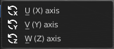
the lattice object along the world axis X, Y or Z .

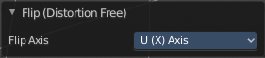
Last Operator Flip (Distortion Free)

Flip Axis
Flip the lattice object along the world axis X, Y or Z .

Single Operators

Make Regular
Set the UVW control points by a uniform distance apart.

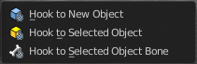
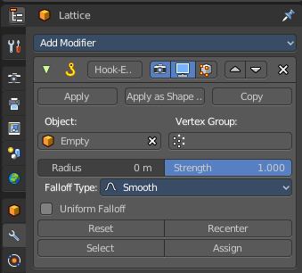
Hooks
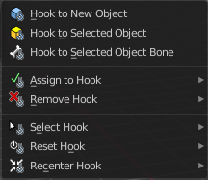
Hooks is a menu with tools around the hook modifier. You could also adjust the hook modifier from the Properties editor. But the menu items are more accessible.
You need to have at least one vertice of the lattice object selected.
When there is no hook modifier at the mesh then you just see three menu items. When there is minimum one hook modifier applied, then you will see an extended menu.

Hook to New Object
Creates a new Hook Modifier for the active object and assigns it to the selected vertices. It also creates an empty at the center of those vertices, which are hooked to it.

Hook to Selected Object
Does the same as Hook to New Object, but instead of hooking the vertices to a new empty, it hooks them to the selected object (if it exists). There should be only one selected object (besides the mesh being edited).

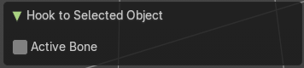
Last Operator Hook to Selected Object

Active Bone
Hook to the object(s) of the active bone.

Hook to Selected Object Bone
Does the same as Hook to New Object. But it sets the last selected bone in the also selected armature as a target.

Assign to Hook
Assign the selected vertices to the chosen hook modifier. Existing hooks gets overwritten. One vertex can be assigned to more than one hook.

Remove Hook
Removes the chosen Hook Modifier from the object.

Select Hook
Selects all vertices assigned to the chosen Hook Modifier.

Reset Hook
Resets the chosen Hook Modifier.

Recenter Hook
Recenter the Hook Modifier.

Make Vertex Parent
Parents an object to the selected vertice(s)
In Object mode select the object that you want to parent to a vertex. Shift select the Lattice object so that both are selected. Enter Edit mode. Then select one vertex for a single point. Or three for an area. Then click the Make Vertex Parent button to make the relation.

